Lab-5-2: Checkpoint

Objectives

- Gather a basic understanding of and experience with Microsoft PowerShell

Preparation
- Open the PowerShell ISE (To do that type ‘powershell’ in the search field on your workstation

- Select Windows PowerShell ISE). You can also perform this lab in the basic PowerShell environment (Windows PowerShell), but you may be missing the code completion facilities of the Interactive Scripting Environment (ISE).

- You can also pin it to your taskbar for ease of access in future.

Exploring PowerShell

Solve the following tasks based on the integrated help (get-help), lecture slides and PowerShell online reference.

Write down the commands you used to achieve the tasks.

- Run FileModifier.jar in live mode and use robocopy to generate log file in the following format:

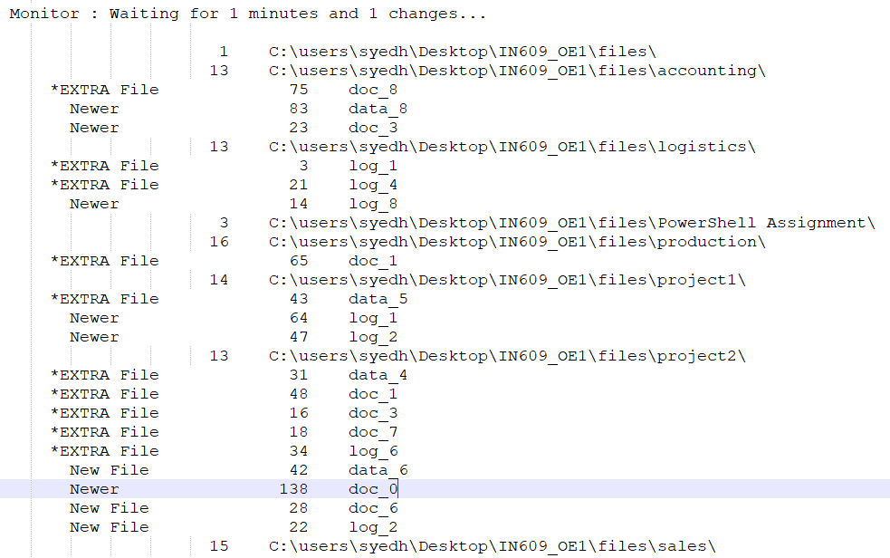

- In the above log file, identify the deleted files and new files. Write a script to create the following logfile that only contains the file name, the operation (deletion/ creation):

DELETED doc_1
CREATED doc_5

